Project Design Phase-II
Data Flow Diagram & User Stories
Date | 14 October 2026
Team ID
Project Name | Employee Raise Issue – Record Producer & Service Portal Integration Guide (ServiceNow)
Maximum Marks | 4 Marks

Data Flow Diagrams:
A Data Flow Diagram (DFD) shows how data enters and leaves the system, what changes the information and where data is stored. The Level 0 DFD below shows how an employee’s issue travels from the Service Portal through the record producer into the Employee raises issue table and on to the support agent.
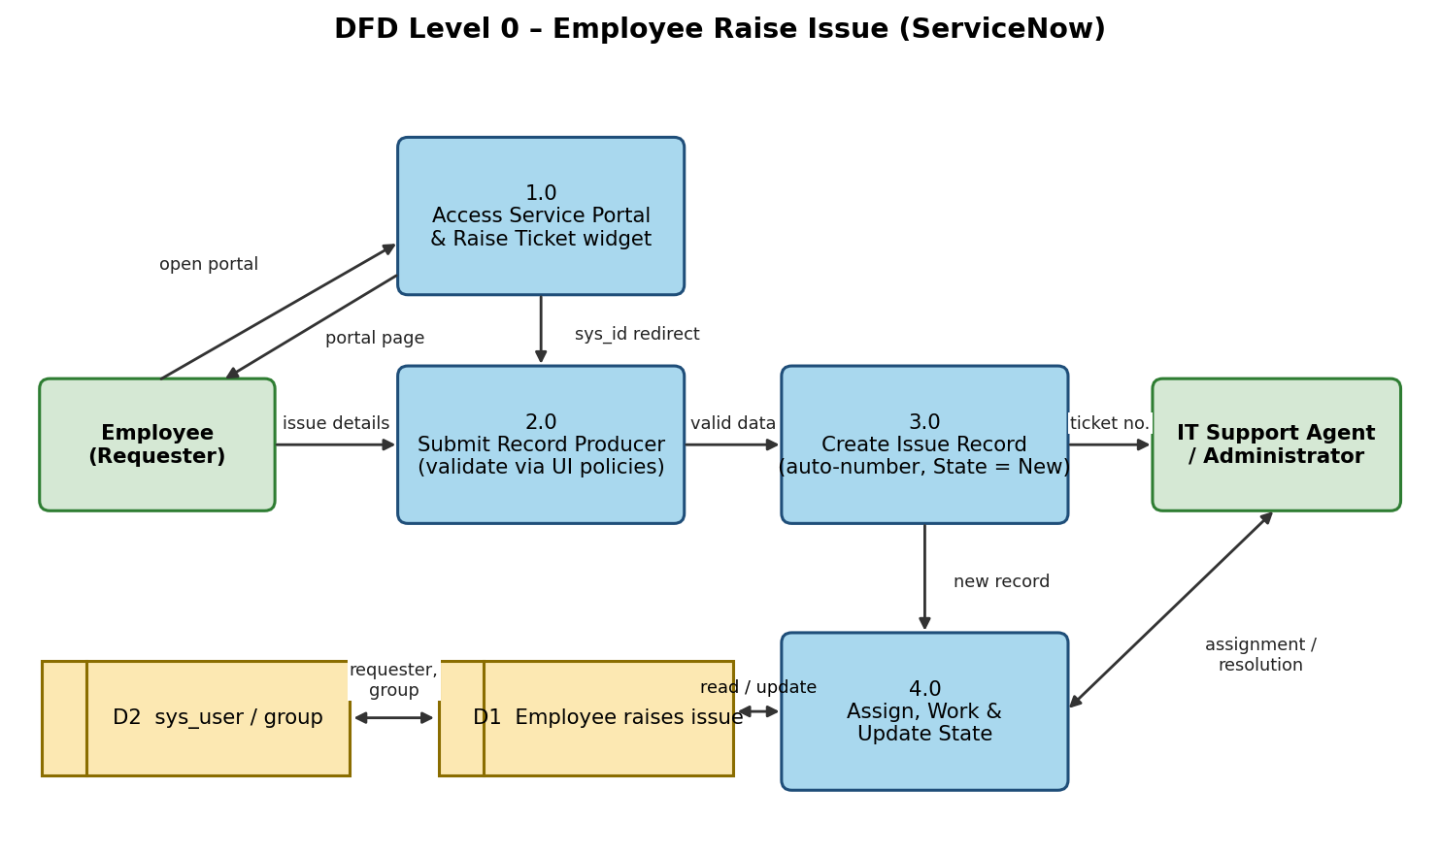
Flow summary: (1) Employee opens the portal and the Raise Ticket widget; (2) the widget redirects to the record producer using its sys_id; (3) the employee submits issue details and UI policies validate them; (4) a record with an auto-generated number is created in table D1; (5) the support agent is assigned and updates the State until the issue is resolved.
User Stories
Use the below table to list all user stories for the product.
User Type | Functional Requirement (Epic) | User Story Number | User Story / Task | Acceptance criteria | Priority | Release
Employee (Portal user) | Access Portal | USN-1 | As an employee, I can open the Requesting portal (/employee_request) and see the logo, banner and widgets. | Portal page loads with the image, icon and both widgets. | High | Sprint-2
 |  | USN-2 | As an employee, I can read the Commercial widget to learn about the support services offered. | Widget shows heading, description and four service points with animation. | Low | Sprint-2
 | Raise Issue | USN-3 | As an employee, I can click the Raise Ticket widget to open the Raise Employee Issue form. | Click redirects to the record producer using its sys_id. | High | Sprint-2
 |  | USN-4 | As an employee, I can fill Requester, Category, Subcategory, State and Short description and submit. | Record is created in the Employee raises issue table with an auto-number. | High | Sprint-1
 |  | USN-5 | As an employee, I see only the subcategories that match my chosen category. | Network→VPN, Hardware→Laptop, Software→Server, Access→Forgot password. | Medium | Sprint-1
 | Validation | USN-6 | As an employee, I am required to enter a short description when State is New. | Short description shows as mandatory; form cannot be submitted without it. | High | Sprint-1
Support Agent | Handle Issue | USN-7 | As a support agent, I can view new issue records with category, priority and assignment group. | List shows submitted records with their numbers. | High | Sprint-3
 |  | USN-8 | As a support agent, I can update State to In progress, Resolved or Closed. | State change is saved and visible on the record. | Medium | Sprint-3
Administrator / Developer | Build & Configure | USN-9 | As an administrator, I can create the custom application, table, fields and auto-numbering. | Table has Number, Requester, Category, Subcategory, Short description, State, Priority, Assignment group. | High | Sprint-1
 |  | USN-10 | As an administrator, I can make the Number field read-only with a UI policy. | Number cannot be edited on the form. | Medium | Sprint-1
 |  | USN-11 | As an administrator, I can create the portal, page and widgets and place them in a 6×6 container. | Both widgets appear side by side on the page. | High | Sprint-2
Employee (Future scope) | Notifications | USN-12 | As an employee, I receive an email when the State of my issue changes. | Notification sent on state change. | Low | Future

